Oracle Business Rule SDK Guide

**Brief Intro of BR:**

Oracle Business Rules is a high performance lightweight business rules product that addresses the requirements for agility, business control, and transparency. It is part of the Fusion Middleware stack and integrates seamlessly across the entire Oracle SOA Suite and BPM Suite stack. It is also a core component for present and future Oracle Fusion Middleware and Fusion Applications products.   
Oracle Business Rules enables its customers to become more agile.   
  
Oracle Business Rules is a component of both [SOA Suite](https://www.oracle.com/technetwork/middleware/soasuite/overview/index.html) and [BPM Suite](https://www.oracle.com/technetwork/middleware/bpm/overview/index.html)

Documentation:

Guide:

<http://citeseerx.ist.psu.edu/viewdoc/download?doi=10.1.1.404.2350&rep=rep1&type=pdf>

SDK:

<https://docs.oracle.com/cd/E28389_01/apirefs.1111/e10663/toc.htm>

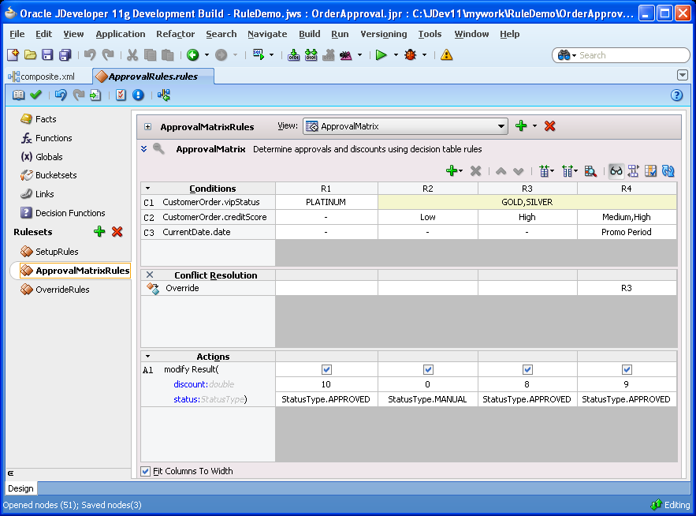

**Business Rule SDK:**

Oracle Business Rules SDK (Rules SDK) lets you write applications that access, create, modify, and execute rules in Oracle Business Rules dictionaries (and work with the contents of a dictionary).

The Rules SDK consists of four areas:

* Engine: provides for rules execution
* Storage: provides access to rule dictionaries and repositories
* Editing: provides a programmatic way to create and modify dictionary components
* Decision Point: provides an interface to access a dictionary and execute a decision function

*More detail see Chapter 7: Working with Rules SDK Decision Point API in Documentation*

**SDK Sample:**

Scenario: According to age of Person to calculate corresponding insurance product

Rule Input: Person with Age

Exception Output: insurance product

Rules overview: there are two rules in this case if person. Age<20 output = “Child Care”

If person. Age>20 output = “People Care”

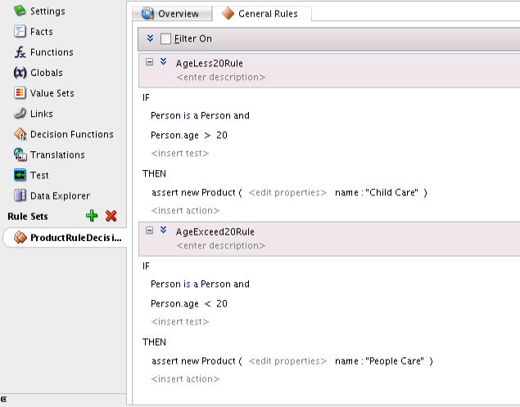

Output log after running rules:

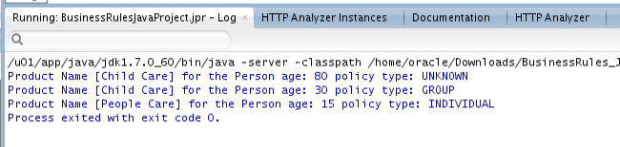

Code Introduction:

1. Define an IF-THEN rule with SDK, more detail please see code comments

InsuranceProductsRules.java -> addIfThenRuleset

1. Define an Decision Table rule with SDK, more detail please see code comments

InsuranceProductsRules.java -> addDecisiontTableRuleToRuleset

1. Invoke rule with SDK, more detail please see code comments

InsuranceProductsRuleClient.java

Imported Library

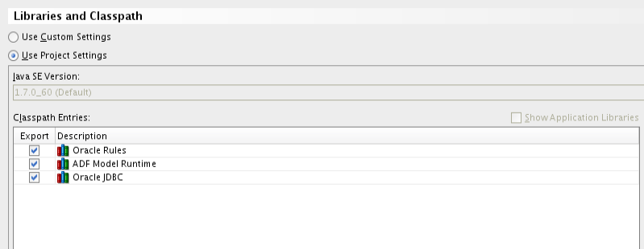

**Code Download Address**

<https://github.com/lzyowen/OracleBusinessRule>

**Working with Rules SDK Decision Point API**

<https://docs.oracle.com/cd/E36909_01/user.1111/e10228/decision_point.htm#CHDJJDEB>